**How to create a VNC server and Connect to a VNC session on Linux:**

1. **Log into the login server and start a VNC server.**
2. Open a terminal and SSH to the server you will be working on. You can use Putty as a terminal to connect to the login server. In our example we will be using salogin02. You may be on one of the other login servers: salogin01, salogin03.
3. Once logged into the server type, **create_vnc** to start your VNC session.   
     
   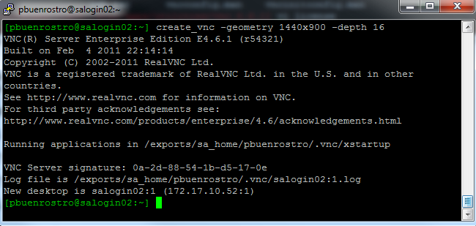

You may use the flag “—geometry” to change the size of the display window  
as the default maybe too small. For example:

create_vnc –geometry 1440x900

You will see output on your screen similar to that above. Make note of the number following the server name. In the example above, it is "salogin02:1".

1 is the port number you will use later to connect to the server.

Your VNC session is now running and ready to connect to. You may now logoff this SSH session.

**3. Log into the VNC session**

1. Launch the VNC Enterprise Edition Viewer from your Windows desktop.
2. Connect to the VNC server by entering the text **salogin02**:1.   
    In our example above, the port number was 1. Therefore, is salogin02:1  
     
   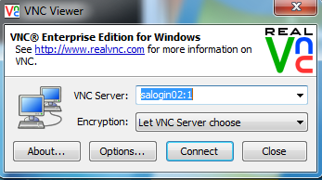

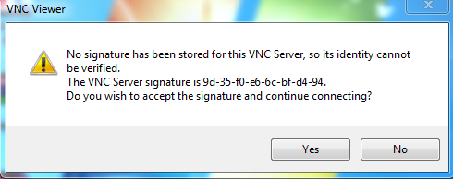

Click Yes

1. Enter your linux password then click connect.

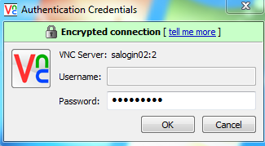

1. **Terminate your VNC session**

***This is only necessary if you won’t need the VNC server anymore***

You can terminate your VNC session with the**-kill** option of the **vncserver** command.

[pbuenrostro@salogin03 ~]$ vncserver –kill :1